

RESEARCH PROJECT PROPOSAL AND PROJECT EXECUTION PLAN

DOCTORAL PROGRAMME IN INFORMATION SCIENCE AND TECHNOLOGY

(Title)

Supervisor/es
XXX X. XXXX, XXXXX Professor, XXXXX-XXX

Candidate
XXX X. XXXX

Lisboa, XXXXXXX XXXX

The project proposal will include the following items (According to the particular aspects of the future PhD thesis proposal):

- Abstract (up to 300 words)
- Table of contents (Index)
- Introduction (up to 500 words)
- Motivation (up to 300 words)
- State of the Art (up to 1500 words)
- Objectives (up to 400 words)
- Research Project Proposal (up to 2000 words)
  - Basis for work development
  - Methods
  - Work description
- Project Execution Plan (up to 2000 words)
  - Project tasks
  - Timeline*
  - Project Outputs
- References**

According to the ﬁeld of interest of PhD thesis.

* Example:
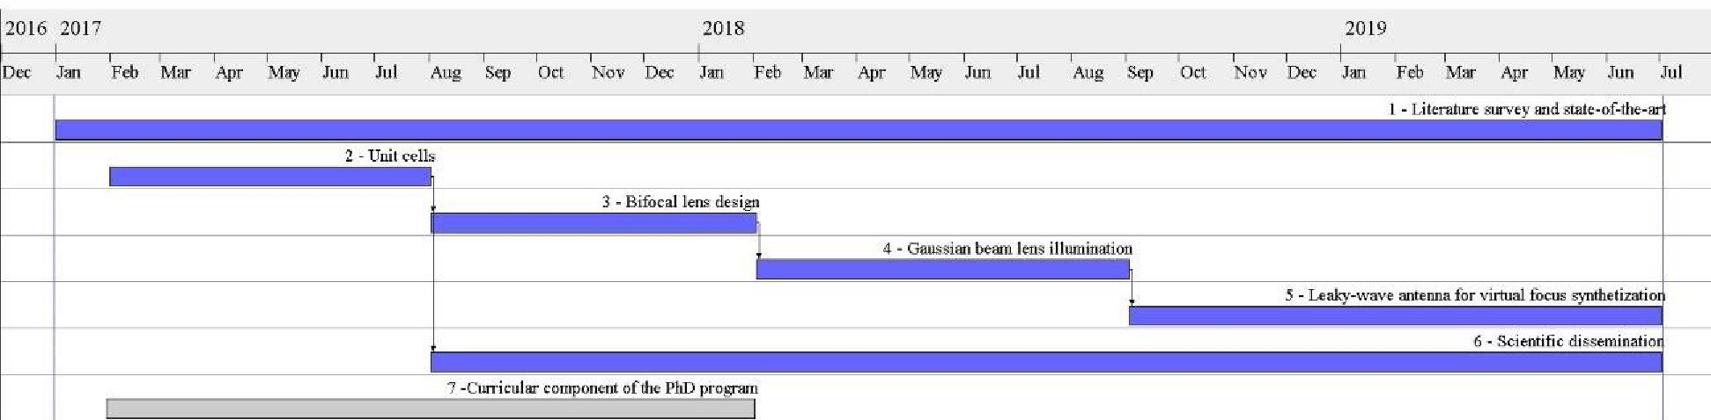

** According to one of the standards used at Iscte-Instituto Universitário de Lisboa, and which in the case of ISTA are: ISO 690, NP 405, Harvard, APA or IEEE.

Example:
T. Chaloun, C. Hillebrand, C. Waldschmidt, and W. Menzel, “Active Transmitarray Submodule for K/Ka Band Satcom Applications,” Proc. 2015 German Microwave Conference (GeMiC), pp. 198 – 201, Nürnberg, Germany, Mar. 2015.

