2nd General Assembly
Iscte – Instituto Universitário de Lisboa
11 – 13 January 2023
Room B1.02
DAY | SCHEDULE | PROPOSED AGENDA
11th January  (Wednesday) | --- | Travel from incoming countries
 | 14:00  14:30 | Welcome / warm-up session  - Welcome message, agenda and local arrangements (Fernando Brito e Abreu)  - EISMEA’s Project Officer message (Ricardo Aguado)  WP1. Project Management and Coordination [EURECAT]  - Schedule and deliverables progress (Ignacio de las Cuevas)  - Financial project execution overview (Astrid Mirabito)  - Data management board status (Roger Calaf Ferrer)
 | 16:00 | Coffee-break
 | 16:30  17:30 | WP5. Piloting Applications with End Users & Monitoring [Heraklion Development Agency]  - Lessons learned and best practices acquired on the 1st Call (Gian Andrea Garancini)  - Preparation of the 2nd Call / Enlarging the potential beneficiaries base (Eva Katsaraki)  BRAINSTORM: Building a community / ecosystem of digital-prone european tourism SMEs  - Context: RESETTING will develop this community to promote co-creation and innovation activities such as twinning, matchmaking, peer learning, and knowledge sharing.  - Issues: How to promote community building? Who (and how) will drive the twinning and matchmaking actions? Who (and how) will drive peer learning and knowledge sharing?  - Kickoff: Salvador Anton Clavé, Gian Andrea Garancini (RESETTING Tourism Experts)
12th January  (Thursday) | 09:00  09:45 | WP4. Training & Capacity Building [Cluster TIC]  - Schedule and deliverables review / progress made and open issues (Monika Hapońska)  - Survey on Digital Transformation in Tourism SMEs - results from the first Open Call  - Pilot mentoring and training activities in Spain  WP2. Data Analytics for Tourism [ISCTE]  - Schedule and deliverables review / progress made and open issues (Sandra Loureiro)  - Digital marketing intelligence (Daniela Langaro)  - Tourism forecasting (Adriano Lopes)
 | 10:30 | Coffee-break
 | 11:00  12:00 | WP3/Task 3.6 - The Sustainable B2B Marketplace [Iscte]  - A cloud-based B2B Marketplace platform to operationalize partnerships between sustainable SMEs and major travel operators (Carlos Coutinho)  - Promoting B2B matchmaking activities in Spain (Sergi Novo Colom)  - Promoting B2B matchmaking activities in Portugal (GEOTA representative)  BRAINSTORM: Building the B2B Marketplace for Sustainable Tourism Experiences and Products (aka STEPS)  - Context: RESETTING will develop a B2B marketplace with procurement facilities to foster the inclusion of STEPS in travel packages offered by major tourism stakeholders.  - Issues: How to promote SMEs’ application throughout consortium countries? Which combination of tourism sustainability (environmental, social, and destination) indicators for assessing STEPS and how should they be made available? How to bridge the gap between SMEs offering STEPS and major travel operators (B2B matchmaking activities)?  - Kickoff: João Joanaz de Melo (FCT/NOVA), Eduardo Moraes Sarmento Ferreira (ISEG/UL)
 | 13:00 | Lunch at Restaurante Clube i – INDEG
 | 14:30 | WP3/Tasks 3.3-3.5 – Smart Tourism Toolkits [ISCTE]  - Smart tourism toolkit for crowding monitoring solutions (Rui Marinheiro)  - Smart tourism toolkit for AR/VR-based tourism experiences (Miguel Dias)  - Smart tourism toolkit for UAV-based live flying tour experiences (Pedro Sebastião)
 | 16:00 | Demos and Posters Session (Atrium B1)  - Coffee-break
 | 17:00  17:45 | WP3/Task 3.2 - The European Observatory of STT [ISCTE]  - Ongoing surveys on (i) what is “Smart Tourism” and (ii) STT taxonomy validation (António Galvão)  - Criteria for choosing a platform-as-a-service cloud-based virtual tradeshow for the European Observatory of STT (Fernando Brito e Abreu)  BRAINSTORM: Building the European Observatory  - Context: RESETTING will develop the European Observatory of Smart Tourism Tools (STT) to provide a classified view of the offer of STTs in Europe. The candidate STTs should have clear value propositions, not affecting the sustainability of destinations.  - Issues: How to complement ST producers’ classification with human validation? How to articulate this observatory with the last two calls for SMEs? How can it help leverage the tourism business? How to provide some guarantee that the Observatory will survive beyond the end of the RESETTING project?  - Kickoff: Salvador Anton Clavé, Gian Andrea Garancini (RESETTING Tourism Experts)
 | 20:00 | Social program (TBD)
13th January  (Friday) | 09:00  09:30 | WP6. Communication & Dissemination [San Benedetto del Tronto City Council]  - Schedule and deliverables review / progress made and open issues (Sergio Trevisani)  - Which communication events are we planning for? How to use Discourse for RESETTING communication and dissemination? (Guido Capanna Piscè)  - Are social networks enough or we should also seek direct contact? (e.g. what would be an effective communication strategy to make big travel / mass tourism operators aware and willing to include the offer of STEPS in their tourism package bundles?  Business Support organizations  - Report of activities by FEHT (David Nadal)  - Report of activities by Albanian Trip (Alda Korumi)  - Report of activities by AUDAX (Pedro Sebastião)
 | 10:30 | Coffee-break
 | 11:00  11:30 | Wrap-up session  RESETTING critical success factors and improvement opportunities (Ignacio de las Cuevas)  Conclusions, required improvements, critical issues and, future work (collective discussion)
 | 1230 | Farewell Porto and group photo
 | --- | Free time to enjoy Lisbon or travel back home

Note: online speakers are marked in blue
Exhibition and International Workshop on Smart Tourism
Iscte – Instituto Universitário de Lisboa
(Atrium B1 - Building II)

12 January 2023

Organizing Chairs: Joana Gouveia Alves, Nuno Miguel Silva

10:30  to  18:30 | - Poster and demo related to the “European Observatory of STT” (António Galvão, Fernando Brito e Abreu)  - Poster on “Digital marketing intelligence” (Pedro de Palma, Daniela Langaro)  - Poster on “Tourism forecasting” (André Garcia, Nuno Dias, Adriano Lopes)  - Poster and demo on the “Crowd monitoring in the Iscte campus” (Tomás Santos, Rui Marinheiro, Fernando Brito e Abreu)  - Poster and demo on a “Geo-temporal crowding visualization in Lisbon” (Rodrigo Simões, Adriano Lopes, Fernando Brito e Abreu)  - Poster and demo on the “Virtual reality experiment in the Iscte campus” (Carlos Portugal, Miguel Dias)  - Poster and demo on the “Assessing the deployment of a walking tour recommendation app” (Daniel Brás, João Almeida, Fernando Brito e Abreu, Rui Marinheiro)  - Poster and demo on the “On using UAVs in tourism experiences” (Gustavo Ferreira, Samuel, Afonso Sampaio, Pedro Sebastião)  - Poster on the “Requirements for a Sustainable B2B Marketplace” (António Galvão, Carlos Coutinho)  - Poster and demo on “Using spatially explicit agent-based simulations for companion modelling with tourism management stakeholders” (Duarte Almeida, Fernando Brito e Abreu, Inês Boavida-Portugal)
16:00  to  17:00 | Tourism experts such as Ignacio de las Cuevas (EURECAT), Sandra Loureiro (BRU-Iscte) and Fernando Brito e Abreu (ISTAR-Iscte) will comment the exhibition in a guided tour.

The Exhibition and International Workshop is co-organized by ISTAR-Iscte and BRU-Iscte and co-funded by Fundação para a Ciência e a Tecnologia, I.P. (FCT) [ISTAR Projects: UIDB/04466/2020 and UIDP/04466/2020] and BRU-Iscte.

General Assembly Venue

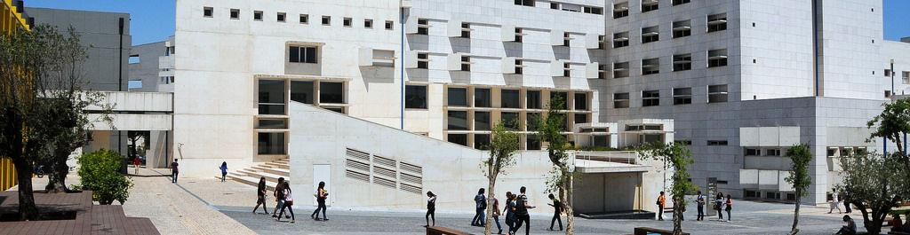

ISCTE is a public university established in 1972 and one of the most dynamic and innovative in Portugal. A leading research university, ISCTE currently has about 9.000 students (17% foreign), over half of them in postgraduate programmes.
​
ISCTE is recognised for excellence in teaching, research and community service, but also for its international and multicultural environment and solid connections to the corporate world that bring real-life business experience to academics and students. ISCTE has been internationally distinguished for relevance and impact, holding accreditations from AACSB and AMBA. Amongst others, ISCTE Business School has been ranked in the top 80 of the best business schools in Europe according to the Financial Times.

How to reach Iscte

The full address is:
ISCTE - Instituto Universitário de Lisboa
Av. das Forças Armadas 36
1649-026 Lisboa

Underground
Lisbon Portela Airport can be reached directly by the Lisbon underground train. This train runs from the airport to the conference location (i.e. Entrecampos Metro Station), and the trip takes about 30 minutes.
​​

Bus
Bus Nº 783: Portela - Aeroporto - Amoreiras
Bus Nº 744: Marquês Pombal – Aeroporto – Moscavide
The trip takes about 30 minutes.
​Taxi or Uber
Taxi / Uber / Bolt
The trip takes about 10 minutes.​

Once You Get to Iscte (Venue Location)

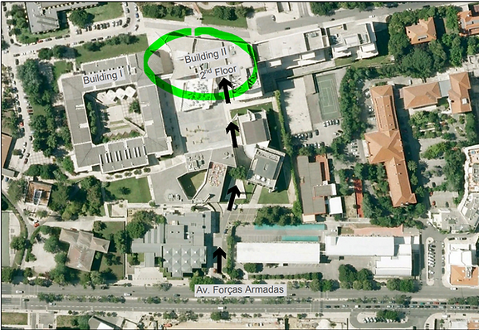
Iscte has an entrance by the main avenue, Forças Armadas and another at the Avenue Professor Aníbal Bettencout, which is direct to the building where the meeting will take place (Room B1.02 on the 1st floor).

Accommodation near Iscte
The nearest hotel is NH. However, I would also advise you to find accommodation close to Campo Pequeno (instead of Entrecampos), since it is not far and there are a lot of restaurants between Campo Pequeno and Gulbenkian Museum. The metro station of Iscte is Entrecampos, yellow line. Anywhere close to the yellow line will be fast (namely Campo Pequeno, Saldanha, and Picoas stations).
Here are some suggestions (prices are indicative as there are lots of options):

Entrecampos metro station:
NH Lisboa Campo Grande – approx. 100€/night (with breakfast)
VIP Executive Entrecampos - Hotel & Conference – approx. 90,20/night (without breakfast)
VIP Executive Zurique Hotel - approx. 85€/night (with breakfast)
The Icons by TRIUS Hotels – approx. 65 €/night

Campo Pequeno metro station:
Alif Campo Pequeno - approx. 100€/night (with breakfast)
Luzeiros Suites – approx. 100€/night
VIP Grand Hotel approx. 125€/night
NCL Rooms and Suits approx. 55€/night

Here you can find some photos of nearby hotels, along with their Tripadvisor ratings:

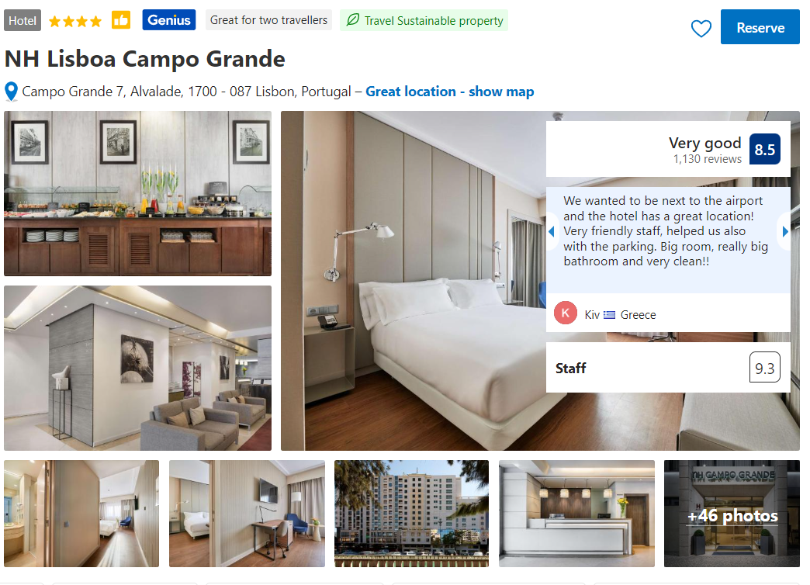
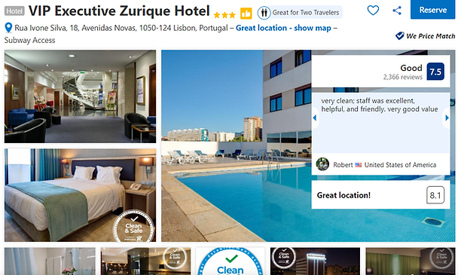

12 minutes walking distance | 5 minutes car/uber/scooter

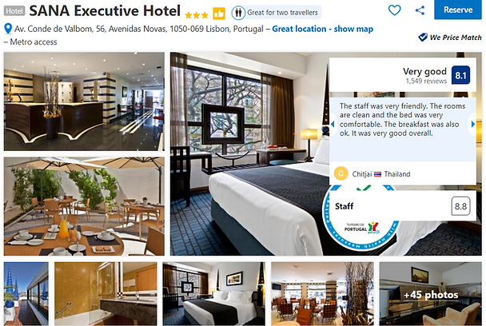

22 minutes walking distance | 7 minutes car/uber/scooter

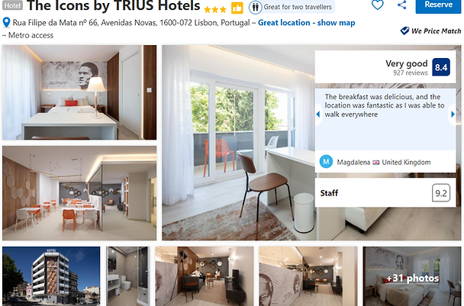

16 minutes walking distance | 4 minutes car/uber/scooter

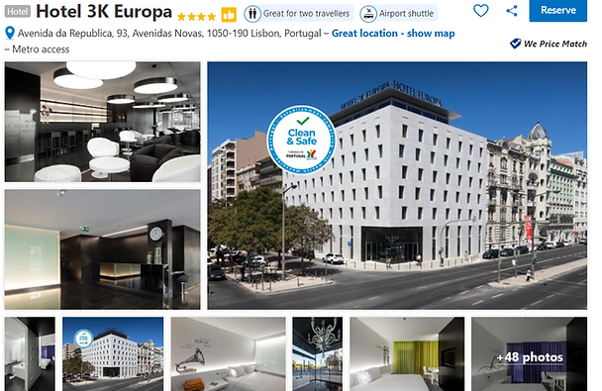

12 minutes walking distance | 7 minutes car/uber/scooter

